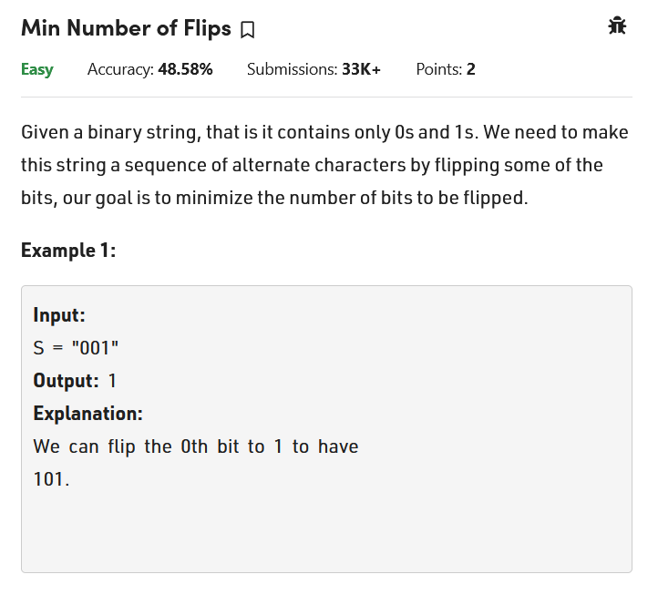

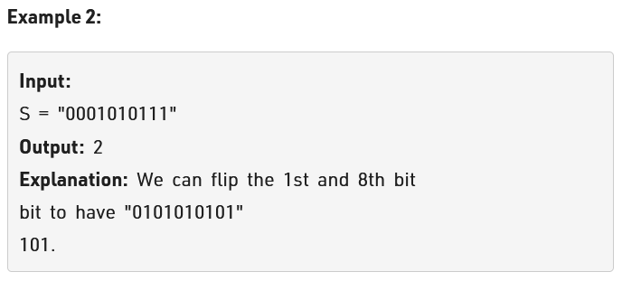

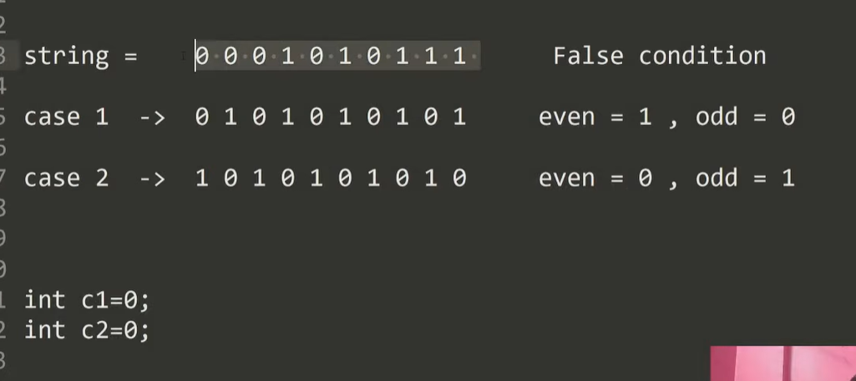

See we only need to see 2 cases that if we can convert the string to alternate or not. Meaning can convert to 101010 or 010101 both are same thing, but we need to see for minimum flips.

See above image string we need to convert either in case1 or case. See here we have c1 and c2 to follow case 1 and case 2.see the logic is that we check case1 whenever not matching we need to flip. Same for case 2 when comparing to string.

See flip is converting o to 1 not same as swaping.

Code:

